|  |  |  |  |  |  |  |  |  |
| --- | --- | --- | --- | --- | --- | --- | --- | --- |
| Team: SIS  Members: Thi-Chi Nguyen, Tien-Luan Vu, Van-Quy Quach, Trong-Uoc Bui  School Name: University of Electronic and Telecomunication  Address: 144 – Xuan Thuy Street, Cau Giay Distict, Ha Noi city, Viet Nam  Size of all team members’ T-shirt   |  |  | | --- | --- | | Thi-Chi Nguyen | M | | Tien-Luan Vu | M | | Van-Quy Quach | M | | Trong-Uoc Bui |  |   The tasks level of design: Level 1 and Level 2. |

**Level 1: Beginner ROM design**

Design ROM and inprove the Cordic v file to meet the input and output specification which is represented in table 6 -1.

1. **Architechture description:** Below is I/O schematic of X_Cordic

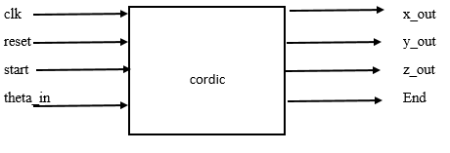

Figure 1. Top level schematic

In cordic block has two smaller block is *cordic_data* and the *controller.* The main task is executed in cordic_data. Block diagram is presented below describing the top level of the design of *cordic_data*.

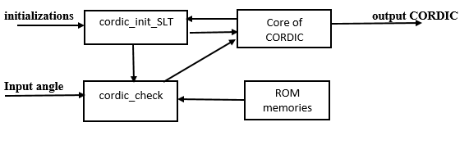

Figure 2. Block diagram of cordic_data

1. **Explanation of the design circuit**

The design circuit step will follow the State Machine representation below:

|  |  |
| --- | --- |
|  | 1. Input*: Start, theta_in* 2. Output: *cos_out, sin_out, End* 3. Wait Step: 4. If(*reset==*1) then 5. *Theta_in;* 6. Goto Start; 7. Else 8. Goto Wait_State; 9. End 10. Start Step: 11. If (*start* == 1) 12. Goto Initialization State; 13. Else 14. Goto wait state; 15. Initialization Step : 16. *Count* ++; 17. Goto Update state; 18. Update step: 19. Update initialized value of ; 20. 69; 21. Goto Checking State; 22. Checking Step: 23. Get value of *alpha* form ROM; 24. If(z_in > theta_in) 25. *alpha_out = - alpha_in* or*;* 26. *x_delta_out = (x_in_check >> address)* – 1; 27. *y_delta_out = (y_in_check >> address)* – 1; 28. Else 29. *alpha_out = alpha_in ;* 30. *x_delta_out = x_in_check >> address;* 31. *y_delta_out = y_in_check >> address;* 32. Goto Computing State; 33. Computing Step: 34. If (reset = 0) 35. *x_out* = 0; 36. *y_out* = 0; 37. else 38. if(*End* = 1) 39. *cos_out = x_out;* 40. *sin_out = y_out;* 41. *z_out = z_out;* 42. else 43. *x_out = x_in - y_delta_in;* 44. *y_out = y_in + x_delta_in;* 45. *z_out = z_in + alpha_in* 46. Goto Update state |

Figure 3. State machine Representation of Cordic

X_cordic architecture is based on the CORDIC method with some improvement to elimilate multiplers. This architecture will take the angle and the initializations of Cordic method such as $x_{0},y_{0},z_{0}$, $x_{0}=0.6072387$ 69, $y_{0}=0∧z_{0}=0.$ it take 1 clock cycle to do this. The *Cordic_init_STL* play the transport role to keep the output of the loop number i as the input of the loop number $i+1$ for *cordic_core* block. Checking block check whether the rotated angle is greater than the input angle or not to decide the direction and updated value to x and y on the next rotation and provide value of *zeta* for Cordic Core. Because the rotation angle are fixed so it need a ROM to save them. ROM has 2^4 * 16 Cell. The main computation is implemented in Cordic core. It take 16 clock cycles to meet End signal enable finish.

1. **An appeal point and originality**

This architecture does not use any multipler and speed up from the frequence 112 Hz to the frequence 146 Hz.

1. **Critical path speed A circuit domain**
2. **HDL. Code** 
   1. **Cordic_init_SLT**

|  |
| --- |
| module codric_init_SLT (  select, // Select as output value from X_init or X_in  x_init, // Initial value of x  y_init, // Initial value of y  z_init, // Initial value of z  x_in, // Itarated value of x  y_in, // Itarated value of y  z_in, // Itarated value of z  x_out, // Selected value of x  y_out, // Selected value of y  z_out // Selected value of z  );  //Inputs  input signed [15:0] x_init;  input signed [15:0] y_init;  input signed [15:0] z_init;  input signed [15:0] x_in;  input signed [15:0] y_in;  input signed [15:0] z_in;  input select;  //Inputs  output signed [15:0] x_out;  output signed [15:0] y_out;  output signed [15:0] z_out;  // Wires  wire signed [15:0] x_out;  wire signed [15:0] y_out;  wire signed [15:0] z_out;  // Select as output value from x_init or x_in  assign x_out = selector_v( x_init, x_in, select);  // Select as output value from y_init or y_in  assign y_out = selector_v( y_init, y_in, select);  // Select as output value from z_init or z_in  assign z_out = selector_v( z_init, z_in, select);  // Select as output value from *_init or *_in  function signed [15:0] selector_v;  input signed [15:0] v_init;  input signed [15:0] v_in;  input select;    if (select) begin  selector_v = v_init;  end else begin  selector_v = v_in;  end  endfunction  endmodule |

* 1. **Cordic_data**

|  |
| --- |
| module cordic_data(  clock, // Input system clock  reset, // Input system reset  End, // Input system End  theta_in, // Input value of theta  x_init, // Initial value of x  y_init, // Initial value of y  z_init, // Initial value of z  select, // Input value of select  address, // Input value of address  x_out, // Output value of x  y_out, // Output value of y  z_out // Output value of z  );  input signed [15:0] x_init;  input signed [15:0] y_init;  input signed [15:0] z_init;  input signed [15:0] theta_in;  input [3:0] address;  input clock;  input reset;  input select;  input End;  output signed [15:0] x_out;  output signed [15:0] y_out;  output signed [15:0] z_out;  wire signed [15:0] X1;  wire signed [15:0] Y1;  wire signed [15:0] Z1;  // wire signed [15:0] DELTA1;  wire signed [15:0] ALPHA1;  // wire signed [15:0] DELTA2;  wire signed [15:0] ALPHA2;  wire signed [15:0] X_FB;  wire signed [15:0] Y_FB;  wire signed [15:0] Z_FB;    wire signed [15:0] y_delta;  wire signed [15:0] x_delta;  assign x_out = X_FB;  assign y_out = Y_FB;  assign z_out = Z_FB;  codric_init_SLT u_codric_init_SLT(  .select (select ), // Select as output value from X_init or X_in  .x_init ( x_init ), // Initial value of x  .y_init ( y_init ), // Initial value of y  .z_init ( z_init ), // Initial value of z  .x_in ( X_FB ), // Itarated value of x  .y_in ( Y_FB ), // Itarated value of y  .z_in ( Z_FB ), // Itarated value of z  .x_out ( X1 ), // Selected value of x  .y_out ( Y1 ), // Selected value of y  .z_out ( Z1 ) // Selected value of z  );  codric_rom u_codric_rom(  .clock ( clock ), // clock input  .address ( address ), // ROM address (0 to 15)  .alpha_out ( ALPHA1 ) // Alpha value : arctan(2^(-i))  // .delta_out ( DELTA1 )  // Delta value : 2^(-i)  );  cordic_check u_cordic_check(  .alpha_in ( ALPHA1 ), // Input value of delta  .theta_in ( theta_in ), // Input value of theta  .x_in_check ( X1 ), // Input value of x_check  .y_in_check ( Y1 ), // Input value of y_check  .address ( address ), // Input value of alpha  .z_in ( Z1 ), // Input value of z  .alpha_out ( ALPHA2 ), // Output value of alpha  .x_delta_out (x_delta), // Output value of x_delta  .y_delta_out ( y_delta ) // Output value of x_delta    );  cordic_core u_cordic_core(  .clock ( clock ), // clock  .xreset ( reset ), // reset (low active)  .End ( End ), // Input value of End  .alpha_in ( ALPHA2 ), // Input value of alpha  .x_delta_in ( x_delta ), // Input value of X_delta  .y_delta_in ( y_delta ), // Input value of y_delta  .x_in ( X1 ), // Input value of x  .y_in ( Y1 ), // Input value of y  .z_in ( Z1 ), // Input value of z  .x_out ( X_FB ), // Output value of x  .y_out ( Y_FB ), // Output value of y  .z_out ( Z_FB ) // Output value of z  );  endmodule |

* 1. **Cordic_core**

|  |
| --- |
| module cordic_core (  clock, // clock  xreset, // reset (low active)  End, // Input value of End  alpha_in, // Input value of alpha  x_delta_in, // Input value of delta  y_delta_in,  x_in, // Input value of x  y_in, // Input value of y  z_in, // Input value of z  x_out, // Output value of x  y_out, // Output value of y  z_out // Output value of z  );  //Inputs  input clock;  input xreset;  input End;  input signed [15:0] x_in;  input signed [15:0] y_in;  input signed [15:0] z_in;  input signed [15:0] alpha_in;  input signed [15:0] x_delta_in;  input signed [15:0] y_delta_in;  //Outputs  output signed [15:0] x_out;  output signed [15:0] y_out;  output signed [15:0] z_out;  //Regs  reg signed [15:0] x_out;  reg signed [15:0] y_out;  reg signed [15:0] z_out;    always @ (posedge clock or negedge xreset) begin  if (xreset == 0) begin  x_out <= 0;  end  else begin  if(End) begin  x_out <= x_out;  end  else begin  x_out <= x_in - y_delta_in;  end  end  end  always @ (posedge clock or negedge xreset) begin  if (xreset == 0) begin  y_out <= 0;  end  else begin  if(End) begin  y_out <= y_out;  end  else begin  y_out <= y_in + x_delta_in;  end  end  end  always @ (posedge clock or negedge xreset) begin  if (xreset == 0) begin  z_out <= 0;  end  else begin  if(End) begin  z_out <= z_out;  end  else begin  z_out <= z_in + alpha_in;  end  end  end  endmodule |

* 1. **Cordic_check**

|  |
| --- |
| module cordic_check (  alpha_in, // Input value of alpha  theta_in, // Input value of theta  x_in_check,  y_in_check,  address,  z_in, // Input value of z  alpha_out, // Output value of alpha  x_delta_out, // Output value of delta  y_delta_out  );  //Inputs  // input signed [15:0] delta_in;  input signed [15:0] alpha_in;  input signed [15:0] theta_in;  input signed [15:0] z_in;  input signed [15:0] x_in_check;  input signed [15:0] y_in_check;  input [3:0] address;  //Outputs  output signed [15:0] x_delta_out;  output signed [15:0] y_delta_out;  output signed [15:0] alpha_out;      //Check z_in and decide to whether invert alpha or not  assign alpha_out = alpha_check( alpha_in, theta_in, z_in);    //Check z_in and decide to whether invert delta or not  assign x_delta_out = x_delta_check( x_in_check, theta_in, z_in);    //Check z_in and decide to whether invert delta or not  assign y_delta_out = y_delta_check( y_in_check, theta_in, z_in);    //wether input z_in is larger than theta or not  function signed [15:0] alpha_check;  input signed [15:0] alpha_in;  input signed [15:0] theta_in;  input signed [15:0] z_in;    if(z_in > theta_in) begin  alpha_check = -alpha_in;  end  else begin  alpha_check = alpha_in;  end  endfunction  //whether input z_in is larger than theta or not  function signed [15:0] x_delta_check;  input signed [15:0] x_in_check;  input signed [15:0] theta_in;  input signed [15:0] z_in;    if(z_in > theta_in) begin    x_delta_check = -(x_in_check >> address)-1;  end  else begin  x_delta_check = x_in_check >> address;  end  endfunction    //whether input z_in is larger than theta or not  function signed [15:0] y_delta_check;  input signed [15:0] y_in_check;  input signed [15:0] theta_in;  input signed [15:0] z_in;  if(z_in > theta_in) begin    y_delta_check = -(y_in_check >> address)-1;  end  else begin  y_delta_check = y_in_check >> address;  end  endfunction  endmodule |

* 1. **Cordic**

|  |
| --- |
| module cordic(  clock, // Input system clock  reset, // Input system reset  start, // Input system start  theta_in, // Input value of theta  x_init, // Initial value of x  y_init, // Initial value of y  z_init, // Initial value of z  x_out, // Output value of x  y_out, // Output value of y  z_out, // Output value of z  End // Output value of End  );  input signed [15:0] x_init;  input signed [15:0] y_init;  input signed [15:0] z_init;  input signed [15:0] theta_in;  input clock;  input reset;  input start;  output signed [15:0] x_out;  output signed [15:0] y_out;  output signed [15:0] z_out;  output End;  wire signed [15:0] theta_out;  wire [3:0] ADDRESS;  wire SELECT;    // PI = 3.141592654 = 2 + 1.141592654(01.00100100001111)  assign theta_out = (theta_in <<1)+theta_in+(theta_in >>3)+(theta_in >>6)+(theta_in >>11)+(theta_in >>12)+(theta_in>>13)+(theta_in >>14);  controler u_controler(    .reset (reset), // Input system clock  .clock (clock), // Input system reset  .start ( start ), // Input value of start  .count ( ADDRESS ), // Output value of CNT  .select ( SELECT ), // Output value of select  .End ( End ) // Output value of END    );  cordic_data u_cordic_data(  .clock ( clock ), // Input system clock  .reset ( reset ), // Input system reset  .End ( End ), // Input system End  .theta_in ( theta_out ), // Input value of theta  .x_init ( x_init ), // Initial value of x  .y_init ( y_init), // Initial value of y  .z_init ( z_init), // Initial value of z  .select ( SELECT ), // Input value of select  .address ( ADDRESS ), //Input value of address  .x_out ( x_out ), // Output value of x  .y_out ( y_out ), // Output value of y  .z_out (z_out ) // Output value of z  );  endmodule |

* 1. **Cordic_sin_cos**

|  |
| --- |
| module sin_cos_cordic(  clock, // Input system clock  reset, // Input system reset  start, // Input system start  theta_in, // Input value of theta  cos_out, // Output value of x  sin_out, // Output value of y  End // Output value of End  );  input clock;  input reset;  input start;  input signed [15:0] theta_in;  output signed [15:0] cos_out;  output signed [15:0] sin_out;  output End;  wire signed [15:0] cos_out;  wire signed [15:0] sin_out;  wire End;  cordic u_cordic (  .clock (clock ), // Input system clock  .reset (reset ), // Input system reset  .start (start ), // Input system start  .theta_in ( theta_in ), // Input value of theta  .x_init ( 16'b0010011011011101 ), // Initial value of x  .y_init ( 16'b0000000000000000 ), // Initial value of y  .z_init ( 16'b0000000000000000 ), // Initial value of z  .x_out ( cos_out ), // Output value of x  .y_out ( sin_out ), // Output value of y  .z_out ( ), // Output value of z  .End ( End ) // Output value of End  );  endmodule |

* 1. **Controller**

|  |
| --- |
| module controler(  reset, // Input system clock  clock, // Input system reset  start, // Input value of start  count, // Output value of CNT  select, // Output value of select  End // Output value of END    );  //Input  input reset;  input clock;  input start;  //Outputs  output [3:0] count;  output select;  output End;  //Reg  reg [3:0] count;  reg count_en;  reg End;    //Wire  wire select;  assign select = start;  always @(posedge clock or negedge reset)  begin  if(reset == 1'b0) begin  count_en <= 0;  end  else begin  if(count == 13) begin  count_en <= 0;  end  else if(start) begin  count_en <= 1;  end  else begin  count_en <= count_en;  end  end  end  always @(posedge clock or negedge reset)  begin  if(reset == 1'b0) begin  count <= 0;  end  else begin  if(count == 13) begin  count <= 0;  end  else if (count_en) begin  count <= count + 1;  end  else if(start) begin  count <= 1;  end  else begin  count <= 0;  end  end  end  always @(posedge clock or negedge reset)  begin  if(reset == 1'b0) begin  End <= 0;    end  else begin  if(count == 13) begin  End <= 1;  end  else begin  End <= 0;  end  end  end  endmodule |

* 1. **Cordic_rom**

|  |
| --- |
| //`defineDvLen 16  `define CORDIC_ROM_DATA_BW 16  module codric_rom (  clock, // clock input  address, // ROM address (0 to 15  alpha_out // Alpha value : arctan(2^(-i))  );  // Inputs  input clock;  input [3:0] address;  // Outputs  output [`CORDIC_ROM_DATA_BW-1:0] alpha_out;  // Regs  reg [`CORDIC_ROM_DATA_BW-1:0] alpha_out;  // ROM for alpha : arctan(2^(-i))  always @ ( negedge clock)  begin  case (address)  0:alpha_out = 16'b0011001001000011 ;// 45 do  1:alpha_out = 16'b0001110110101100 ;  2:alpha_out = 16'b0000111110101101 ;  3:alpha_out = 16'b0000011111110101 ;  4:alpha_out = 16'b0000001111111110 ;  5:alpha_out = 16'b0000000111111111 ;  6:alpha_out = 16'b0000000011111111 ;  7:alpha_out = 16'b0000000001111111 ;  8:alpha_out = 16'b0000000000111111 ;  9:alpha_out = 16'b0000000000011111 ;  10:alpha_out = 16'b0000000000001111 ;  11:alpha_out = 16'b0000000000000111 ;  12:alpha_out = 16'b0000000000000011 ;  13:alpha_out = 16'b0000000000000001 ;  14:alpha_out = 16'b0000000000000000 ;  15:alpha_out = 16'b0000000000000000 ;    endcase  end  endmodule |

* 1. **Sin_cos_cordic_tb**

|  |
| --- |
| `timescale 1ns / 1ns  module cordic_tb;  //Inputs  reg clock;  reg reset;  reg start;  reg signed [15:0] theta_in;  //Outputs  wire signed [15:0] x_out;  wire signed [15:0] y_out;  wire End;  parameter STEP = 1000;  sin_cos_cordic u_sin_cos_cordic(  clock, // Input system clock  reset, // Input system reset  start, // Input system start  theta_in, // Input value of theta  x_out, // Output value of x  y_out, // Output value of y  End  );  always #(STEP/2) clock = ~clock;  initial begin  //initialize  #0 reset = 0;  clock = 0;  start = 0;  theta_in = 0;  #(STEP) //theta_in is PI/4 value  // theta_in = 16'b0001000000000000;  //theta_in is PI1/8 value  theta_in = 16'b0000100000000000;  //theta_in is PI2/8 value  //theta_in = 16'b0001000000000000;  //theta_in is PI3/8 value  //theta_in = 16'b0001100000000000;  //theta_in is PI4/8 value  //theta_in = 16'b0010000000000000;  //theta_in is -PI1/8 value  //theta_in = 16'b1111100000000000;  //theta_in is -PI2/8 value  //theta_in = 16'b1111000000000000;  //theta_in is -PI3/8 value  //theta_in = 16'b1110100000000000;  //theta_in is -PI4/8 value  //theta_in = 16'b1110000000000000;  //theta_in is 0 value  //theta_in = 16'b0000000000000000;  //theta_in is 1/128 value  //theta_in = 16'b0000000010000000;  //theta_in is 1/256 value  //theta_in = 16'b0000000001000000;  //theta_in is -1/128 value  //theta_in = 16'b1111111110000000;  //theta_in is -1/256 value  //theta_in = 16'b1111111111000000;  //theta_in is PI4/8 - 1/128 value  //theta_in = 16'b0001111111010111;  //theta_in is PI4/8 - 1/256 value  //theta_in = 16'b0001111111101011;  //theta_in is -PI4/8 + 1/128 value  //theta_in = 16'b1110000000101001;  //theta_in is -PI4/8 + 1/256 value  //theta_in = 16'b1110000000010101;      reset = 1;    #(STEP) start = 1;  #(STEP) start = 0;  #(STEP*14)  $finish;  end  initial  $monitor ( $stime,"theta_in = %b x_out = %b y_out = %b End = %b",theta_in, x_out, y_out, End);    endmodule |

1. **Operation**

When *reset* is high *theta_in* input is sampled by testbench and x_Cordic processing is started as soon as meet a rising clock and *start* is high. Form starting, each loop take 1 clock cycle.

Regarding output CORDIC handling, there is *End* pin – when high means that the processing stop and give the final output.

Below is example of computing trigonometric function by x_Cordic

Example: For angle = PI/8 we meet the output specification.

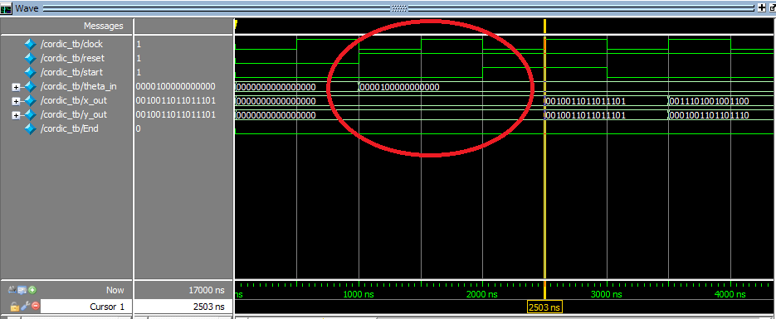

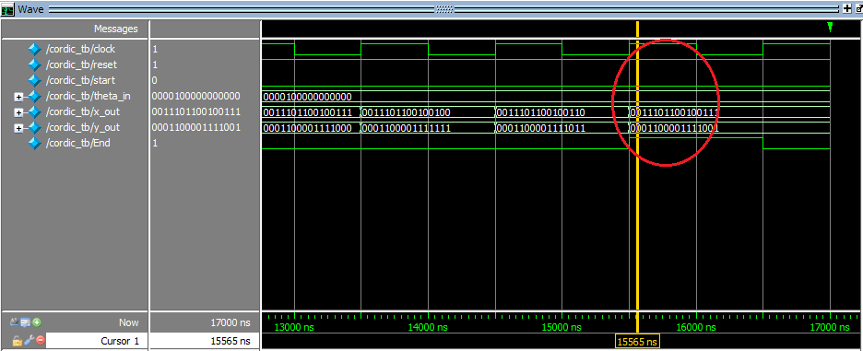

Figure 4. Cordic operation

1. **Synthesize**
   1. **Timming**

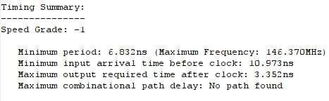

* 1. **Source**

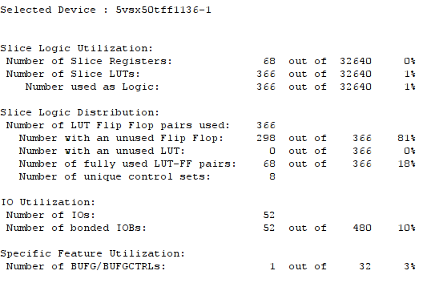

* 1. **Component**

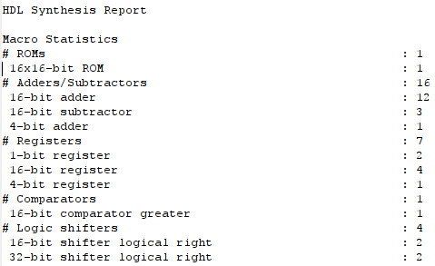

|  |  |  |
| --- | --- | --- |
| **Design** | **Xilinx Virtex-5 (XC5VLX50-1ff324)** | |
| **NOS** | **MUF** |
| **Conventional CORDIC** | **178** | **109,005 MHz** |
| **Our design** | **361** | **146,370 MHz** |

**NOS stands for the number of slices. MUF stands for maximum operationg frequency in MHz**

**Level 2: For experts Trigonometric function output using a variety of algorithms.**

1. **Introduction**

Pramod Kumar Meher and Sang Yoon Park [1] said that it is observed that the hardware-complexity of barrel-shifters alone is nearly half of that of a CORDIC circuit. Therefore they suggested some techniques to minimize the complexity of barrel shifters. And, they have proved by experiment that a set of four selected micro-rotations is enough to achieve with maximum angular deviation $Δϕ={0.04}^{0}$. Terence K. Rodrigues and Earl E. Swartzlander. Jr [2] have proposed a simple implementation of the angle selection scheme that allows the Angle Recoding method to be used dynamically for any arbitrary angle of rotation. This methosd determind the boundaries of the contiguous ranges of $α$ to predict the ranges of $θ$ (= $Z_{0}$ by define $m_{i}$ as follows:

$m_{i}=\frac{a_{i+1}+a_{i}}{2}∀i=0…n−1$

So if |Z| then |Z| is closer to $α_{i}$ and if |Z| <, then |Z| is closer to $α_{i+1}$. This given the more than 50% reduction in the number of interations, but this is to define all the possible rangles for a given angle constant, we must find all the combinations of angle constants that include it.

1. **Architecture**

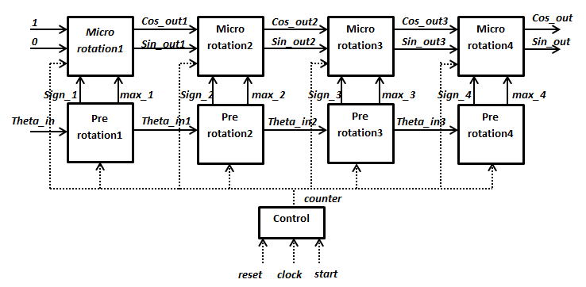

Figure 5. Architecture

As show in figure 4, our architecture has 9 main blocks: 4 pre_rotation blocks, 4 micro_rotation blocks and control block. In here, control block is aim to generated control signal. The $n^{th}$ pre_rotation block is to find the direction and the magnitude of rotated angle in the $n^{th}$ micro rotation. Finally, the $n^{th}$ micro_rotation block performs the rotation with the found rotated angle.

Next, the detail of above blocks will be clarified in the next section.

* 1. **Pre_rotation block.**

The following figure will illustrated the process in pre_rotation block more clearly:

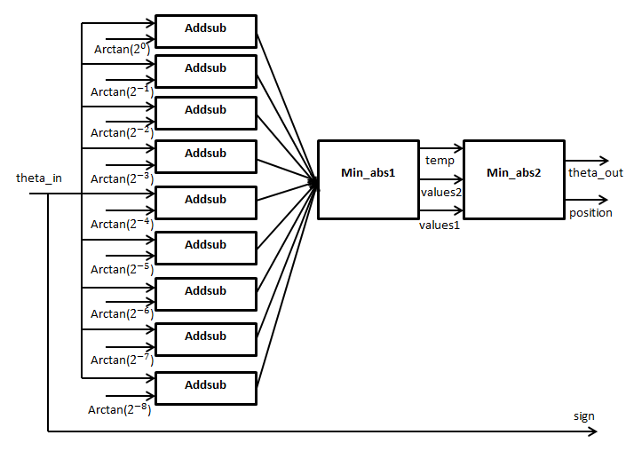

Figure 6. Pre_rotation

In our architecture, depending on the sign of the theta_in in each micro rotation, we will perform 9 addition or subtraction between this angle with 9 angles which have values of arctan($2^{−i}$) with i in range from 0 to 8, and we denote 9 results by angle_temp(i). After that, they were used in min_abs1 block to find a set containing two values and have the minimum absolute values. Because the values of arctan($2^{−i}$) is decrease when i increase, 9 values of angle_temp(i) is monotonic. Therefore, if all values of angle_temp(i) is in the same direction, we will choose the initial and final value to return to min_abs2 block. If not, we will return two consecutive results which have opposite sign. Because suppose that we find angle_temp(k) and angle_temp(k+1) which has different sign, there are two cases:

If ${angle}_{temp}\left(k\right)≤0≤{angle}_{temp}\left(k+1\right)$ then angle_temp(k) has minimum absolute in the set of negative values and angle_temp(k+1) has minimum absolute in the set of positive values.

If ${angle}_{temp}\left(k\right)≥0≥{angle}_{temp}\left(k+1\right)$ then angle_temp(k) has minimum absolute in the set of negative values and angle_temp(k+1) has minimum absolute in the set of positive values.

In both case, output of min_abs1 block always has the values which has minimum absolute.

The last block in pre_rotation is min_abs2. It perform compare the absolute of two values in output of min_abs1 block and return the position of angle we choose to rotate to support for micro_rotation block.

In addion, the sign of theta_in is stored to determine the direction of rotation in micro_rotation block.

* 1. **Micro_rotation block.**

This block is illustrated by the following figure:

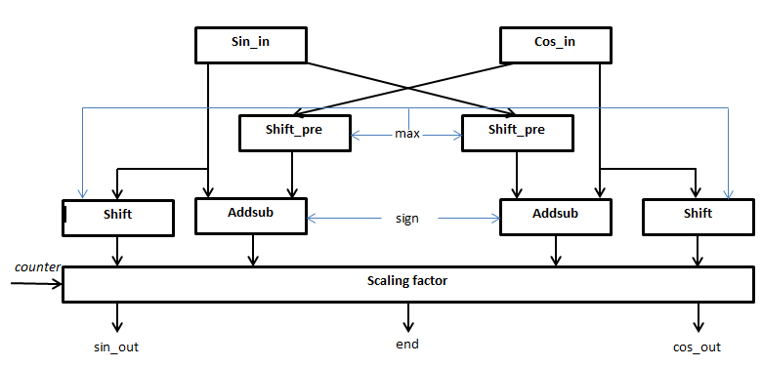

Figure 7. Micro_rotation block

This block contain three main processes: pre_shift, addsub and multiplied with scaling factor. Firstly, sin_in and cos_in values is pre_shift max bit by load (16-max) bit less significant bit from the value of sin_in and cos_in, other bits is equal the sign bit of sin_in and cos_in. After that, we will perform addition or subtraction depending on the value of sign. Finally, The results after addsub is multiplied with scaling factor.

The scaling factor is $K=\frac{1}{\sqrt{1+2^{−2i}}}=1−\frac{1}{2^{2i+1}}+\frac{3}{2^{4i+3}}−…$

To gain the accuracy of 8 bit, we will use $K_{i}=\frac{1}{\sqrt{1+2^{−2i}}}=1−\frac{1}{2^{2i+1}}$ with $i≥2$. In the cases $i=1∧i=0,$ we will use the true values which were stored in ROM.

* 1. **Control block**

The control block is simplied a generation of counter signal to count the number of clock cycles and controls blocks to perform in time. In addition, counter signal also detect the point of time the system is finished and end signal is equal 1.

1. **An appeal point and originality**

In our architecture, by find the rotated angle that nearest input theta_in in each micro rotation, we have already reduced the number of iteration from 9 to 4 iterations, so we could reduced delay of the system. For the reason that each iteration consumes only one clock cycles, our system consumes only 4 clock cycles to gain the results. When compare with 14 clock cycles consuming in the architecture in level 1, It is can be easy to seen that our architecture can gain lower delay than that one in level 1.

orther appeal point in our architecture is the way to find the element that has smallest absolute from a set of 9 elements by searching two consecutive results which have opposite sign. If we can not find, we can return the set containing the initial and final element. This step helps us to reduce the complexity of comparators from 16 bit to only 1 bit. Therefore, it reduces delay to find the element which has the smallest absolute.

1. **Critical path speed a circuit domain**

Timing constraint: Default period analysis for Clock 'clock'

Clock period: 7.427ns (frequency: 134.644MHz)

Total number of paths / destination ports: 8724094 / 256

-------------------------------------------------------------------------

Delay: 7.427ns (Levels of Logic = 38)

Source: pre_rotation2/min_abs_step1/values_out1_0 (FF)

Destination: pre_rotation3/min_abs_step1/values_out2_14 (FF)

Source Clock: clock rising

Destination Clock: clock rising

Data Path: pre_rotation2/min_abs_step1/values_out1_0 to pre_rotation3/min_abs_step1/values_out2_14

1. **HDL code (VHDL)**
   1. **Addsub**

|  |
| --- |
| library ieee;  use ieee.std_logic_1164.all;  use ieee.numeric_std.all;  use ieee.std_logic_unsigned.all;  entity addsub is  port(  sign: in std_logic;  theta_in: in std_logic_vector(15 downto 0);  angle_in: in std_logic_vector(15 downto 0);  angle_temp: out std_logic_vector(15 downto 0)  );  end entity;  architecture addsub of addsub is  begin  angle_temp <= theta_in-angle_in when (sign='0')  else  theta_in+angle_in;  end architecture;  -------------------------------------------------------- |

* 1. **Shift**

|  |
| --- |
| library ieee;  use ieee.std_logic_1164.all;  use ieee.std_logic_arith.all;  entity shift is  port(  inbus: in std_logic_vector(15 downto 0);  round: in std_logic_vector(3 downto 0);  outbus: out std_logic_vector(15 downto 0)  );  end entity;  architecture shift of shift is  begin  outbus <= inbus when ( round="0000")  else inbus(15)&inbus(15)&inbus(14 downto 1) when (round="0001")  else inbus(15)&inbus(15)&inbus(15)&inbus(14 downto 2) when (round="0010")  else inbus(15)&inbus(15)&inbus(15)&inbus(15)&inbus(14 downto 3) when (round="0011")  else inbus(15)&inbus(15)&inbus(15)&inbus(15)&inbus(15)&inbus(14 downto 4) when (round="0100")  else inbus(15)&inbus(15)&inbus(15)&inbus(15)&inbus(15)&inbus(15)&inbus(14 downto 5) when (round="0101")  else inbus(15)&inbus(15)&inbus(15)&inbus(15)&inbus(15)&inbus(15)&inbus(15)&inbus(14 downto 6) when (round="0110")  else inbus(15)&inbus(15)&inbus(15)&inbus(15)&inbus(15)&inbus(15)&inbus(15)&inbus(15)&inbus(14 downto 7) when (round="0111")  else inbus(15)&inbus(15)&inbus(15)&inbus(15)&inbus(15)&inbus(15)&inbus(15)&inbus(15)&inbus(15)&inbus(14 downto 8) when (round="1000")  else (others=>'0');  end architecture; |

* 1. **Min_abs1**

|  |
| --- |
| library ieee;  use ieee.std_logic_1164.all;  use ieee.numeric_std.all;  use ieee.std_logic_unsigned.all;  entity min_abs1 is  port(  counter: in std_logic_vector(3 downto 0);  clock: in std_logic;  angle0: in std_logic_vector(15 downto 0);  angle1: in std_logic_vector(15 downto 0);  angle2: in std_logic_vector(15 downto 0);  angle3: in std_logic_vector(15 downto 0);  angle4: in std_logic_vector(15 downto 0);  angle5: in std_logic_vector(15 downto 0);  angle6: in std_logic_vector(15 downto 0);  angle7: in std_logic_vector(15 downto 0);  angle8: in std_logic_vector(15 downto 0);  new_max: out std_logic_vector(3 downto 0);  values_out1: out std_logic_vector(15 downto 0);  values_out2: out std_logic_vector(15 downto 0)  );  end entity;  architecture min_abs1 of min_abs1 is  begin  process(angle0,clock)  begin  if (rising_edge(clock)) then  if (counter/="0000") then  if angle0(15)/=angle4(15) then  if angle0(15)/=angle2(15) then  if angle0(15)/=angle1(15) then  new_max <="0000";  values_out1 <= angle0;  values_out2 <= angle1;  else  new_max <="0001";  values_out1 <= angle1;  values_out2 <= angle2;  end if;  else  if(angle2(15)/=angle3(15)) then  new_max <= "0010";  values_out1 <= angle2;  values_out2 <= angle3;  else  new_max <= "0011";  values_out1 <= angle3;  values_out2 <= angle4;  end if;  end if;  elsif( angle4(15)/=angle8(15)) then  if angle4(15)/=angle6(15) then  if angle4(15)/=angle5(15) then  new_max <= "0100";  values_out1 <= angle4;  values_out2 <= angle5;  else  new_max <= "0101";  values_out1 <= angle5;  values_out2 <= angle6;  end if;  else  if (angle6(15)/=angle7(15)) then  new_max <="0110";  values_out1 <= angle6;  values_out2 <= angle7;  else  new_max <="0111";  values_out1 <= angle7;  values_out2 <= angle8;  end if;  end if;  else  new_max <= "1000";  values_out1 <=angle0;  values_out2 <= angle8;  end if;  end if;  end if;  end process;  end architecture; |

* 1. **Min_abs2**

|  |
| --- |
| library ieee;  use ieee.std_logic_1164.all;  use ieee.numeric_std.all;  use ieee.std_logic_unsigned.all;  entity min_abs2 is  port(  values_out1: in std_logic_vector(15 downto 0);  values_out2: in std_logic_vector(15 downto 0);  new_max: in std_logic_vector(3 downto 0);  max: out std_logic_vector(3 downto 0);  values_out: out std_logic_vector(15 downto 0)  );  end entity;  architecture min_abs2 of min_abs2 is  signal sum, sub: std_logic_vector(15 downto 0);  component sum_sub is  port(  values_out1: in std_logic_vector(15 downto 0);  values_out2: in std_logic_vector(15 downto 0);  sum: out std_logic_vector(15 downto 0);  sub: out std_logic_vector(15 downto 0)  );  end component;begin  sum_sub1: sum_sub port map(  values_out1 => values_out1,  values_out2 => values_out2,  sum => sum,  sub => sub);  values_out <= values_out1 when ((new_max="1000" and sub(15)/=values_out1(15)) or (new_max/="1000" and sum(15)/=values_out1(15)))  else values_out2;  max <= "1000" when ((new_max="1000") and (sub(15)=values_out1(15)))  else "0000" when ((new_max="1000") and (sub(15)/=values_out1(15)))  else new_max+"0001" when ((new_max/="1000" and sum(15)=values_out1(15)))  else new_max;  end architecture; |

* 1. **Cordic**

|  |
| --- |
| library ieee;  use ieee.std_logic_1164.all;  use ieee.numeric_std.all;  use ieee.std_logic_unsigned.all;  entity cordic is  port(  sin_in: std_logic_vector(15 downto 0);  cos_in: std_logic_vector(15 downto 0);  max: in std_logic_vector(3 downto 0);  sign: in std_logic;  cos_out: out std_logic_vector(15 downto 0);  sin_out: out std_logic_vector(15 downto 0)  );  end entity;  architecture cordic of cordic is  component shift is  port(  inbus: in std_logic_vector(15 downto 0);  round: in std_logic_vector(3 downto 0);  outbus: out std_logic_vector(15 downto 0)  );  end component;  component addsub is  port(  sign: in std_logic;  theta_in: in std_logic_vector(15 downto 0);  angle_in: in std_logic_vector(15 downto 0);  angle_temp: out std_logic_vector(15 downto 0)  );  end component;  component scaling_factor is  port(  max: in std_logic_vector(3 downto 0);  sin_in: in std_logic_vector(15 downto 0);  cos_in: in std_logic_vector(15 downto 0);  sin_out: out std_logic_vector(15 downto 0);  cos_out: out std_logic_vector(15 downto 0)  );  end component;  begin  not_sign <= not sign;  shift1: shift port map (  inbus => sin_in,  round => max,  outbus => sin_shift  );  shift2: shift port map (  inbus => cos_in,  round => max,  outbus => cos_shift  );  addsub1: addsub port map (  sign => not_sign,  theta_in => cos_in,  angle_in => sin_shift,  angle_temp => t_cos  );  addsub2: addsub port map (  sign => sign,  theta_in => sin_in,  angle_in => cos_shift,  angle_temp => t_sin  );  scaling_factor1: scaling_factor port map(  max => max,  sin_in => t_sin,  cos_in => t_cos,  cos_out => cos_out,  sin_out => sin_out  );  end architecture; |

* 1. **K1**

|  |
| --- |
| library ieee;  use ieee.std_logic_1164.all;  use ieee.numeric_std.all;  use ieee.std_logic_unsigned.all;  entity k1 is  port(  sin_in: in std_logic_vector(14 downto 0);  cos_in: in std_logic_vector(14 downto 0);  sin_temp1: out std_logic_vector(15 downto 0);  cos_temp1: out std_logic_vector(15 downto 0)  );  end entity;  architecture k1 of k1 is  signal sin_temp: std_logic_vector(15 downto 0);  signal cos_temp: std_logic_vector(15 downto 0);  begin    sin_temp <= (sin_in(14)&sin_in)  +(sin_in(14)&sin_in(14)&sin_in(14)&sin_in(14)&sin_in(14)&sin_in(14)&sin_in(14 downto 5));  cos_temp <= (cos_in(14)&cos_in)  + (cos_in(14)&cos_in(14)&cos_in(14)&cos_in(14)&cos_in(14)&cos_in(14)&cos_in(14 downto 5));  sin_temp1 <= sin_temp+(sin_temp(15)&sin_temp(15)&sin_temp(15 downto 2));  cos_temp1 <= cos_temp+(cos_temp(15)&cos_temp(15)&cos_temp(15 downto 2));  end architecture; |

* 1. **Sum_sub**

|  |
| --- |
| library ieee;  use ieee.std_logic_1164.all;  use ieee.numeric_std.all;  use ieee.std_logic_unsigned.all;  entity sum_sub is  port(  values_out1: in std_logic_vector(15 downto 0);  values_out2: in std_logic_vector(15 downto 0);  sum: out std_logic_vector(15 downto 0);  sub: out std_logic_vector(15 downto 0)  );  end entity;  architecture sum_sub of sum_sub is  begin  sum <= values_out1+values_out2;  sub <= values_out1-values_out2;  end architecture; |

* 1. **Scaling_factor**

|  |
| --- |
| library ieee;  use ieee.std_logic_1164.all;  use ieee.numeric_std.all;  use ieee.std_logic_unsigned.all;  entity scaling_factor is  port(  max: in std_logic_vector(3 downto 0);  sin_in: in std_logic_vector(15 downto 0);  cos_in: in std_logic_vector(15 downto 0);  sin_out: out std_logic_vector(15 downto 0);  cos_out: out std_logic_vector(15 downto 0)  );  end entity;  architecture scaling_factor of scaling_factor is  component k1 is  port(  sin_in: in std_logic_vector(14 downto 0);  cos_in: in std_logic_vector(14 downto 0);  sin_temp1: out std_logic_vector(15 downto 0);  cos_temp1: out std_logic_vector(15 downto 0)  );  end component;  component shift is  port(  inbus: in std_logic_vector(15 downto 0);  round: in std_logic_vector(3 downto 0);  outbus: out std_logic_vector(15 downto 0)  );  end component;  signal sin_temp1,cos_temp1: std_logic_vector(15 downto 0);  signal t_sin_in,t_cos_in,t_sin_in1,t_cos_in1,t_sin_in2,t_cos_in2: std_logic_vector(15 downto 0);  begin  scaling_shift1: shift port map(  inbus => cos_in,  round => max,  outbus => t_cos_in1  );  scaling_shift2: shift port map(  inbus => sin_in,  round => max,  outbus => t_sin_in1  );  scaling_shift3: shift port map(  inbus => t_cos_in1,  round => max,  outbus => t_cos_in2  );  scaling_shift4: shift port map(  inbus => t_sin_in1,  round => max,  outbus => t_sin_in2  );  scaling_shift5: shift port map(  inbus => t_cos_in2,  round => "0001",  outbus => t_cos_in  );  scaling_shift6: shift port map(  inbus => t_sin_in2,  round => "0001",  outbus => t_sin_in  );  k11: k1 port map(  sin_in => sin_in(15 downto 1),  cos_in => cos_in(15 downto 1),  sin_temp1 => sin_temp1,  cos_temp1 => cos_temp1  );  sin_out <= sin_temp1+(sin_in(15)&sin_in(15)&sin_in(15)&sin_in(15)&sin_in(15 downto 4)) when (max="0000")  else sin_temp1+(sin_in(15)&sin_in(15)&sin_in(15 downto 2)) when (max="0001")  else sin_in when (max="1000")  else sin_in-t_sin_in;    cos_out <= cos_temp1+(cos_in(15)&cos_in(15)&cos_in(15)&cos_in(15)&cos_in(15 downto 4)) when (max="0000")  else cos_temp1+(cos_in(15)&cos_in(15)&cos_in(15 downto 2)) when (max="0001")  else cos_in when (max="1000")  else cos_in-t_cos_in;  end architecture; |

* 1. **Pre_rotation**

|  |
| --- |
| library ieee;  use ieee.std_logic_1164.all;  use ieee.std_logic_arith.all;  entity pre_rotation is  port(  counter: in std_logic_vector(3 downto 0);  clock: in std_logic;  theta_in: in std_logic_vector(15 downto 0);  sign: out std_logic;  max: out std_logic_vector(3 downto 0);  values_out: out std_logic_vector(15 downto 0)  );  end entity;  architecture pre_rotation of pre_rotation is  signal angle_temp0,angle_temp1,angle_temp2,angle_temp3,angle_temp4,angle_temp5,angle_temp6,angle_temp7,angle_temp8: std_logic_vector(15 downto 0);--9 gia tri angle sau khi add/sub  signal new_max: std_logic_vector(3 downto 0);--gia tri nhan duoc sau buoc 1 khoi min_abs  signal t_sign: std_logic;  signal values_out1,values_out2: std_logic_vector(15 downto 0);  component addsub is  port(  sign: in std_logic;  theta_in: in std_logic_vector(15 downto 0);  angle_in: in std_logic_vector(15 downto 0);  angle_temp: out std_logic_vector(15 downto 0)  );  end component;  component min_abs1 is  port(  counter: in std_logic_vector(3 downto 0);  clock: in std_logic;  angle0: in std_logic_vector(15 downto 0);  angle1: in std_logic_vector(15 downto 0);  angle2: in std_logic_vector(15 downto 0);  angle3: in std_logic_vector(15 downto 0);  angle4: in std_logic_vector(15 downto 0);  angle5: in std_logic_vector(15 downto 0);  angle6: in std_logic_vector(15 downto 0);  angle7: in std_logic_vector(15 downto 0);  angle8: in std_logic_vector(15 downto 0);  new_max: out std_logic_vector(3 downto 0);  values_out1: out std_logic_vector(15 downto 0):=(others=>'0');  values_out2: out std_logic_vector(15 downto 0):=(others=>'0')  );  end component;  component min_abs2 is  port(  values_out1: in std_logic_vector(15 downto 0);  values_out2: in std_logic_vector(15 downto 0);  new_max: in std_logic_vector(3 downto 0);  max: out std_logic_vector(3 downto 0);  values_out: out std_logic_vector(15 downto 0)  );  end component;  begin  t_sign <= theta_in(15);  addsub0: addsub port map(  sign => t_sign,  theta_in => theta_in,  angle_in => "0000000000010100",  angle_temp => angle_temp8  );  addsub1: addsub port map(  sign => t_sign,  theta_in => theta_in,  angle_in => "0000000000101000",  angle_temp => angle_temp7  );  addsub2: addsub port map(  sign => t_sign,  theta_in => theta_in,  angle_in => "0000000001010001",  angle_temp => angle_temp6  );  addsub3: addsub port map(  sign => t_sign,  theta_in => theta_in,  angle_in => "0000000010100100",  angle_temp => angle_temp5  );  addsub4: addsub port map(  sign => t_sign,  theta_in => theta_in,  angle_in => "0000000101000101",  angle_temp => angle_temp4  );  addsub5: addsub port map(  sign => t_sign,  theta_in => theta_in,  angle_in => "0000001010001000",  angle_temp => angle_temp3  );  addsub6: addsub port map(  sign => t_sign,  theta_in => theta_in,  angle_in => "0000010011111101",  angle_temp => angle_temp2  );  addsub7: addsub port map(  sign => t_sign,  theta_in => theta_in,  angle_in => "0000100101110010",  angle_temp => angle_temp1  );  addsub8: addsub port map(  sign => t_sign,  theta_in => theta_in,  angle_in => "0001000000000000",  angle_temp => angle_temp0  );  min_abs_step1: min_abs1 port map(  counter => counter,  clock => clock,  angle0 => angle_temp0,  angle1 => angle_temp1,  angle2 => angle_temp2,  angle3 => angle_temp3,  angle4 => angle_temp4,  angle5 => angle_temp5,  angle6 => angle_temp6,  angle7 => angle_temp7,  angle8 => angle_temp8,  new_max => new_max,  values_out1 => values_out1,  values_out2 => values_out2  );  min_abs_step2: min_abs2 port map(  values_out1 => values_out1,  values_out2 => values_out2,  new_max => new_max,  max => max,  values_out => values_out  );  sign <= not theta_in(15);  end architecture; |

* 1. **system**

|  |
| --- |
| library ieee;  use ieee.std_logic_1164.all;  use ieee.std_logic_arith.all;  entity system is  port(  reset: in std_logic;  start: in std_logic;  clock: in std_logic;  theta_in: in std_logic_vector(15 downto 0);  cos_out: out std_logic_vector(15 downto 0);  sin_out: out std_logic_vector(15 downto 0);  t_end: out std_logic:='0'  );  end entity;  architecture system of system is  signal t_end1: std_logic:='0';  signal t_values_out1,t_values_out2,t_values_out3,t_values_out4: std_logic_vector(15 downto 0);  signal sign1,sign2,sign3,sign4: std_logic;  signal max1,max2,max3,max4: std_logic_vector(3 downto 0);  signal sin_out1,sin_out2,sin_out3,sin_out4: std_logic_vector(15 downto 0  signal cos_out1,cos_out2,cos_out3,cos_out4: std_logic_vector(15 downto 0);  signal counter: std_logic_vector(3 downto 0);  component control is  port(  reset: in std_logic;  clock: in std_logic;  start: in std_logic;  counter: out std_logic_vector(3 downto 0)  );  end component;  component pre_rotation is  port(  counter: in std_logic_vector(3 downto 0);  clock: in std_logic;  theta_in: in std_logic_vector(15 downto 0);  sign: out std_logic;  max: out std_logic_vector(3 downto 0);  values_out: out std_logic_vector(15 downto 0)  );  end component;  component cordic is  port(  sin_in: std_logic_vector(15 downto 0);  cos_in: std_logic_vector(15 downto 0);  max: in std_logic_vector(3 downto 0);  sign: in std_logic;  cos_out: out std_logic_vector(15 downto 0);  sin_out: out std_logic_vector(15 downto 0)  );  end component;  begin  control1: control port map(  reset => reset,  clock => clock,  start => start,  counter => counter  );  pre_rotation1: pre_rotation port map(  counter => counter,  clock => clock,  theta_in => theta_in,  sign => sign1,  max => max1,  values_out => t_values_out1  );  rotation1: cordic port map(  sin_in => x"0000",  cos_in => x"4000",  max => max1,  sign => sign1,  cos_out => cos_out1,  sin_out => sin_out1  );  pre_rotation2: pre_rotation port map(  counter => counter,  clock => clock,  theta_in => t_values_out1,  sign => sign2,  max => max2,  values_out => t_values_out2  );  rotation2: cordic port map(  sin_in => sin_out1,  cos_in => cos_out1,  max => max2,  sign => sign2,  cos_out => cos_out2,  sin_out => sin_out2  );  pre_rotation3: pre_rotation port map(  counter => counter,  clock => clock,  theta_in => t_values_out2,  sign => sign3,  max => max3,  values_out => t_values_out3  );  rotation3: cordic port map(  sin_in => sin_out2,  cos_in => cos_out2,  max => max3,  sign => sign3,  cos_out => cos_out3,  sin_out => sin_out3  );  pre_rotation4: pre_rotation port map(  counter => counter,  clock => clock,  theta_in => t_values_out3,  sign => sign4,  max => max4,  values_out => t_values_out4  );  rotation4: cordic port map(  sin_in => sin_out3,  cos_in => cos_out3,  max => max4,  sign => sign4,  cos_out => cos_out4,  sin_out => sin_out4  );  t_end1 <= '1' when (counter>"0100")  else '0';  t_end <= t_end1;  cos_out <= cos_out4 when (t_end1='1')  else (others =>'0');  sin_out <= sin_out4 when (t_end1 ='1')  else (others=>'0');    end architecture; |

1. **The display of a simulation waveform which the design is operating**

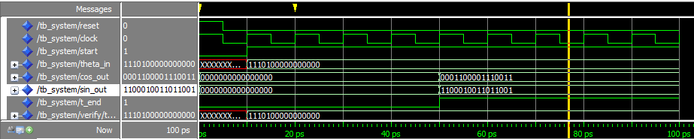

Figure 8. Simulation waveform

With theta_in=”1110010000000000” then sin_out = “1100010011011001” and cos_out=”0001100001110011”.

We have the result table:

|  |  |  |  |  |
| --- | --- | --- | --- | --- |
| Theta_in | Output | | True value | |
| Cos_out | Sin_out | Cos_out | Sin_out |
| $\frac{π}{2}$ | 0000000000000000 | 0011111111111101 | 0000000000000000 | 0100000000000000 |
| $\frac{π}{2}−\frac{π}{256}$ | 0000000001111110 | 0011111111111100 | 0000000011001001 | 0011111111111111 |
|  | 0000000101111110 | 0011111111111100 | 0000000110010010 | 0011111111111011 |
|  | 0001100001110001 | 0011101100100111 | 0001100001111101 | 0011101100100000 |
|  | 0010110100010011 | 0010110101101101 | 0010110101000001 | 0010110101000001 |
| $\frac{π}{8}$ | 0011101100110111 | 0001100001010000 | 0011101100100000 | 0001100001111101 |
| $\frac{π}{128}$ | 0011111111111100 | 0000000110000001 | 0011111111111011 | 0000000011001001 |
| $\frac{π}{256}$ | 0100000000000000 | 0000000011000001 | 0011111111111110 | 1111111100110111 |
| 0 | 0100000000000000 | 0000000000000000 | 0100000000000000 | 0000000000000000 |
| $\frac{−π}{256}$ | 0011111111111100 | 1111111010000001 | 0011111111111110 | 1111111100110111 |
| $\frac{−π}{128}$ | 0011111111111111 | 1111111101000000 | 0011111111111011 | 1111111001101110 |
| $\frac{−π}{8}$ | 0011101100111000 | 1110011110110010 | 0011101100100000 | 1110011110000011 |
| $\frac{−π}{4}$ | 0010110101101110 | 1101001011101101 | 0010110101000001 | 1101001010111111 |
|  | 0001100001110011 | 1100010011011001 | 0001100001111101 | 1100010011100000 |
| $\frac{−π}{2}+\frac{π}{128}$ | 0000000011000000 | 1100000000000100 | 0000000110010010 | 1100000000000010 |
| $\frac{−π}{2}+\frac{π}{256}$ | 0000000010000000 | 1100000000000011 | 0000000011001001 | 1100000000000010 |
| $\frac{−π}{2}$ | 0000000000000000 | 1100000000000011 | 0000000000000000 | 1100000000000000 |

|  |
| --- |
| *Table 2: Result* |

1. **Synthesize**
   1. **Timming**

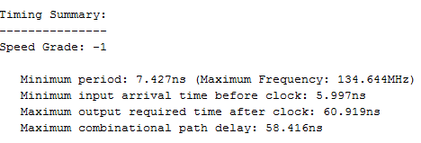

* 1. **Source**

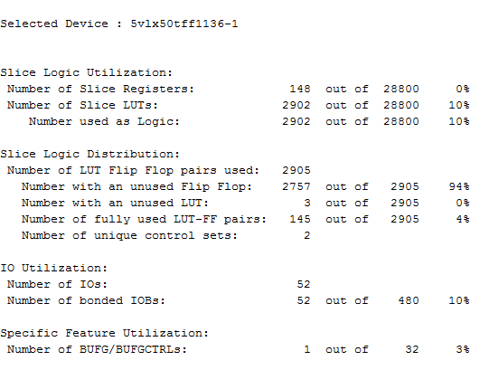

* 1. **Component**

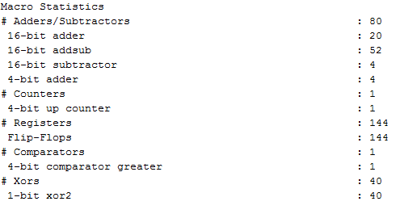

**************************************Thank you**************************************